Ex.no:9 | MINI PROJECT – HEALTHCARE DATA ANALYTICS

Aim:
To perform healthcare data analytics using Python, Power BI, and Tableau by cleaning and analyzing patient healthcare records, identifying patterns in medical conditions, admission types, test results, medications, billing amounts, and hospital stay duration, and presenting the findings through interactive visualizations and dashboards.
Algorithm:
- Import the healthcare dataset into Python using Pandas.
- Examine the dataset structure, columns, data types, missing values, and duplicate records.
- Remove duplicate records from the dataset.
- Convert the admission and discharge date columns into the datetime format.
- Calculate the length of hospital stay using the admission and discharge dates.
- Create additional attributes such as admission year, admission month, month name, year-month, and age groups.
- Calculate important statistical measures such as total records, total billing amount, average billing amount, average age, and average length of stay.
- Analyze medical conditions, admission types, medications, insurance providers, and test results.
- Create visualizations using Python Matplotlib.
- Import the healthcare dataset into Power BI and create DAX measures for healthcare KPIs.
- Create interactive Power BI charts, cards, and slicers.
- Import the dataset into Tableau and create worksheets and an interactive healthcare analytics dashboard.
- Compare and interpret the results obtained from the different analytical tools.
- Present the final healthcare analytics findings.

Architecture:
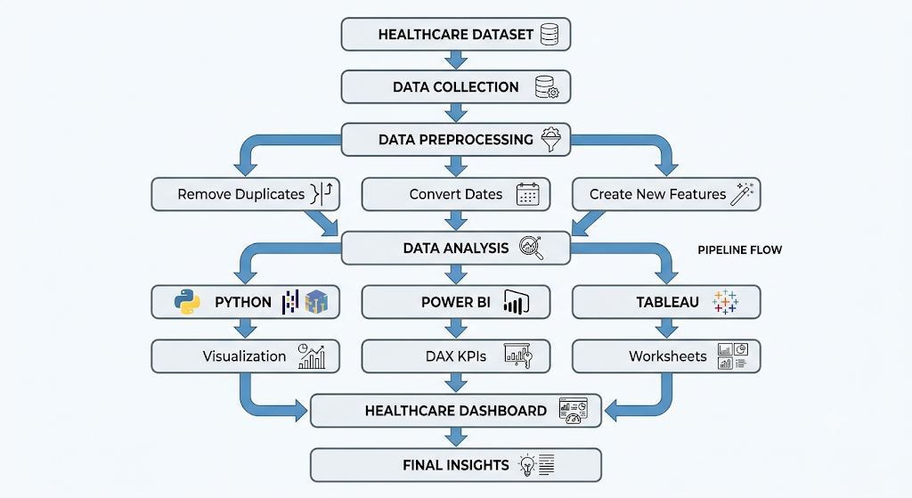
Program:
1. Python
import pandas as pd
import matplotlib.pyplot as plt
# Load dataset
df = pd.read_csv('healthcare_dataset.csv')
# Create a copy
healthcare = df.copy()
# Remove duplicate records
healthcare = healthcare.drop_duplicates()
# Convert dates
healthcare['Date of Admission'] = pd.to_datetime(
healthcare['Date of Admission']
)
healthcare['Discharge Date'] = pd.to_datetime(
healthcare['Discharge Date']
)
# Calculate length of stay
healthcare['Length of Stay'] = (
healthcare['Discharge Date'] -
healthcare['Date of Admission']
).dt.days
# Create date features
healthcare['Admission Year'] = \
healthcare['Date of Admission'].dt.year
healthcare['Admission Month'] = \
healthcare['Date of Admission'].dt.month
healthcare['Admission Month Name'] = \
healthcare['Date of Admission'].dt.month_name()
healthcare['Year-Month'] = \
healthcare['Date of Admission'].dt.to_period('M').astype(str)
# Create age groups
healthcare['Age Group'] = pd.cut(
healthcare['Age'],
bins=[0, 17, 30, 45, 60, 75, 120],
labels=['0-17', '18-30', '31-45',
'46-60', '61-75', '76+']
)
# Basic analysis
print("Total Records:", len(healthcare))
print("Total Billing Amount:",
round(healthcare['Billing Amount'].sum(), 2))
print("Average Billing Amount:",
round(healthcare['Billing Amount'].mean(), 2))
print("Average Age:",
round(healthcare['Age'].mean(), 2))
print("Average Length of Stay:",
round(healthcare['Length of Stay'].mean(), 2))
print(healthcare['Medical Condition'].value_counts())
print(healthcare['Admission Type'].value_counts())
print(healthcare['Medication'].value_counts())
print(healthcare['Test Results'].value_counts())
# Medical condition visualization
healthcare['Medical Condition'].value_counts().plot(
kind='bar',
figsize=(10,5)
)
plt.title('Patients by Medical Condition')
plt.xlabel('Medical Condition')
plt.ylabel('Number of Patient Records')
plt.xticks(rotation=45)
plt.tight_layout()
plt.show()
# Admission type visualization
healthcare['Admission Type'].value_counts().plot(
kind='bar',
figsize=(8,5)
)
plt.title('Patients by Admission Type')
plt.xlabel('Admission Type')
plt.ylabel('Number of Patient Records')
plt.tight_layout()
plt.show()
# Test results visualization
healthcare['Test Results'].value_counts().plot(
kind='bar',
figsize=(7,5)
)
plt.title('Patient Test Results')
plt.xlabel('Test Result')
plt.ylabel('Number of Patient Records')
plt.tight_layout()
plt.show()

2. Power BI DAX
Total Patient Records =
COUNTROWS('healthcare_dataset')
Total Billing Amount =
SUM('healthcare_dataset'[Billing Amount])
Average Billing Amount =
AVERAGE('healthcare_dataset'[Billing Amount])
Average Age =
AVERAGE('healthcare_dataset'[Age])
Average Length of Stay =
AVERAGEX(
'healthcare_dataset',
DATEDIFF(
'healthcare_dataset'[Date of Admission],
'healthcare_dataset'[Discharge Date],
DAY
)
)
Power BI visualizations created:
- Total Patient Records – Card
- Total Billing Amount – Card
- Average Billing Amount – Card
- Average Age – Card
- Average Length of Stay – Card
- Patients by Medical Condition – Column Chart
- Patients by Admission Type – Column Chart
- Average Billing by Medical Condition – Bar Chart
- Monthly Patient Admissions – Line Chart
- Patient Test Results – Donut Chart
- Average Billing by Insurance Provider – Bar Chart
Slicers used:
- Gender
- Medical Condition
- Admission Type
- Insurance Provider

Output:
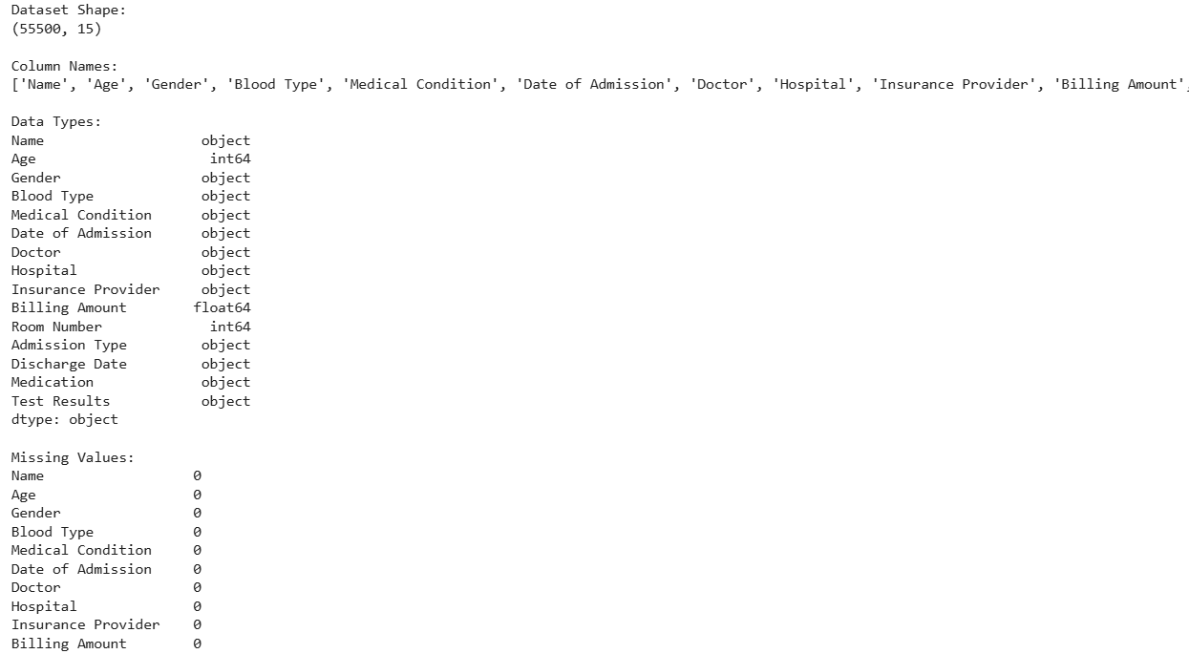
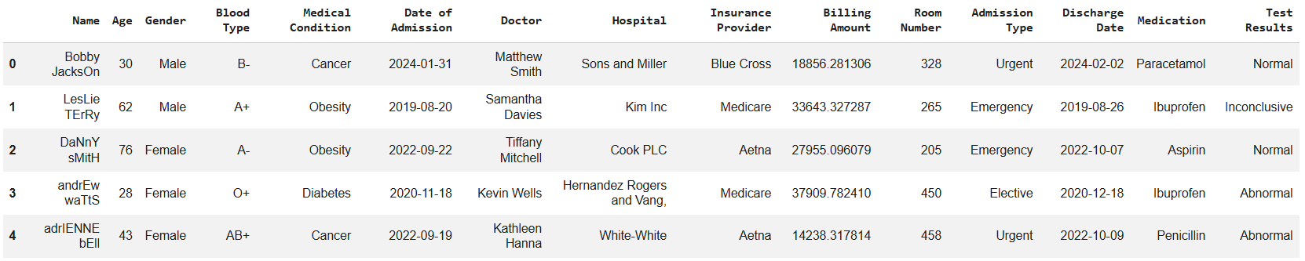
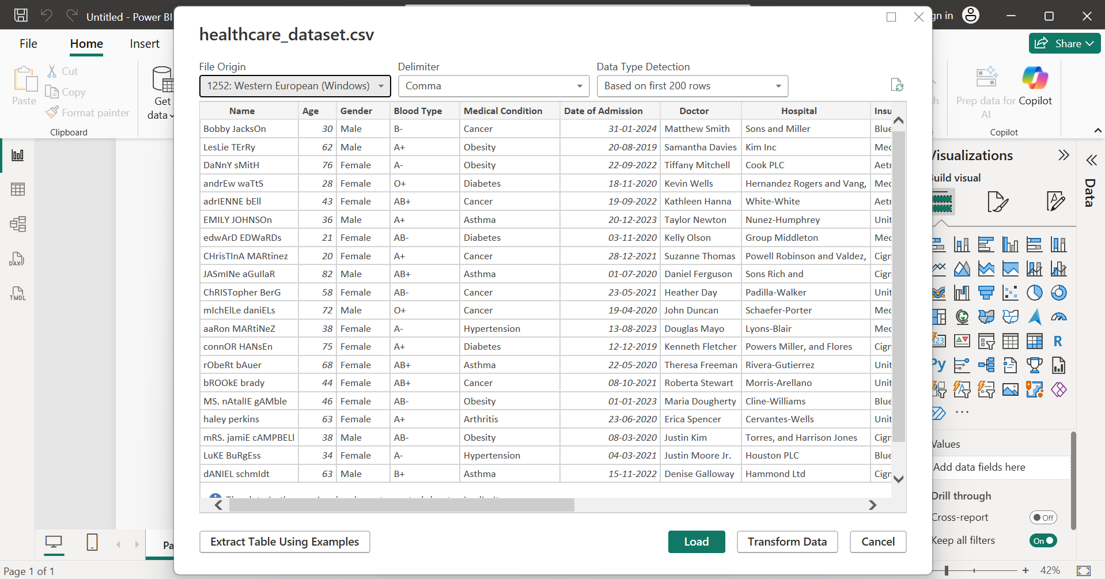
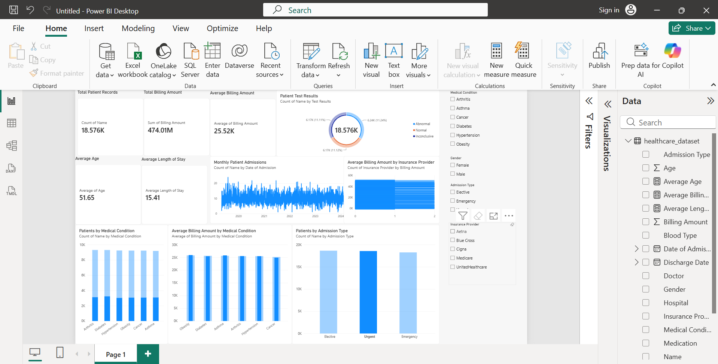
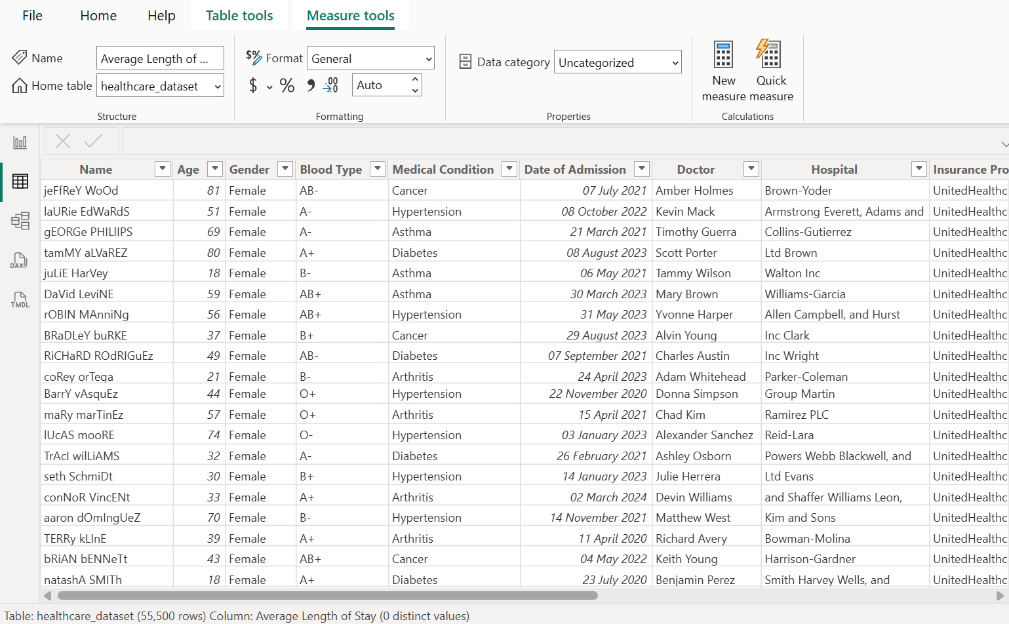
3. Tableau
The healthcare dataset was connected to Tableau and the following worksheets were created:
- Patients by Medical Condition
- Admission Type Analysis
- Average Billing by Condition
- Monthly Admissions Trend
- Test Results Analysis
- Insurance Billing Analysis
These worksheets were combined into an interactive Healthcare Analytics Dashboard. Filters were added for Gender, Medical Condition, Admission Type, and Insurance Provider.
Output
The healthcare dataset initially contained 55,500 records and 15 attributes. The dataset contained 534 duplicate records and no missing values. After removing duplicate records, 54,966 records remained for analysis.
Key Results
Metric | Result
Total Records after Cleaning | 54,966
Total Billing Amount | 1,404,068,339.23
Average Billing Amount | 25,544.31
Average Age | 51.54 years
Average Length of Stay | 15.5 days
Most Common Medical Condition | Arthritis
Most Common Admission Type | Elective
Most Common Medication | Lipitor
Test Results
Test Result | Number of Records
Abnormal | 18,437
Normal | 18,331
Inconclusive | 18,198
The analysis was visualized using Python charts, Power BI dashboards, and Tableau worksheets.

Output:
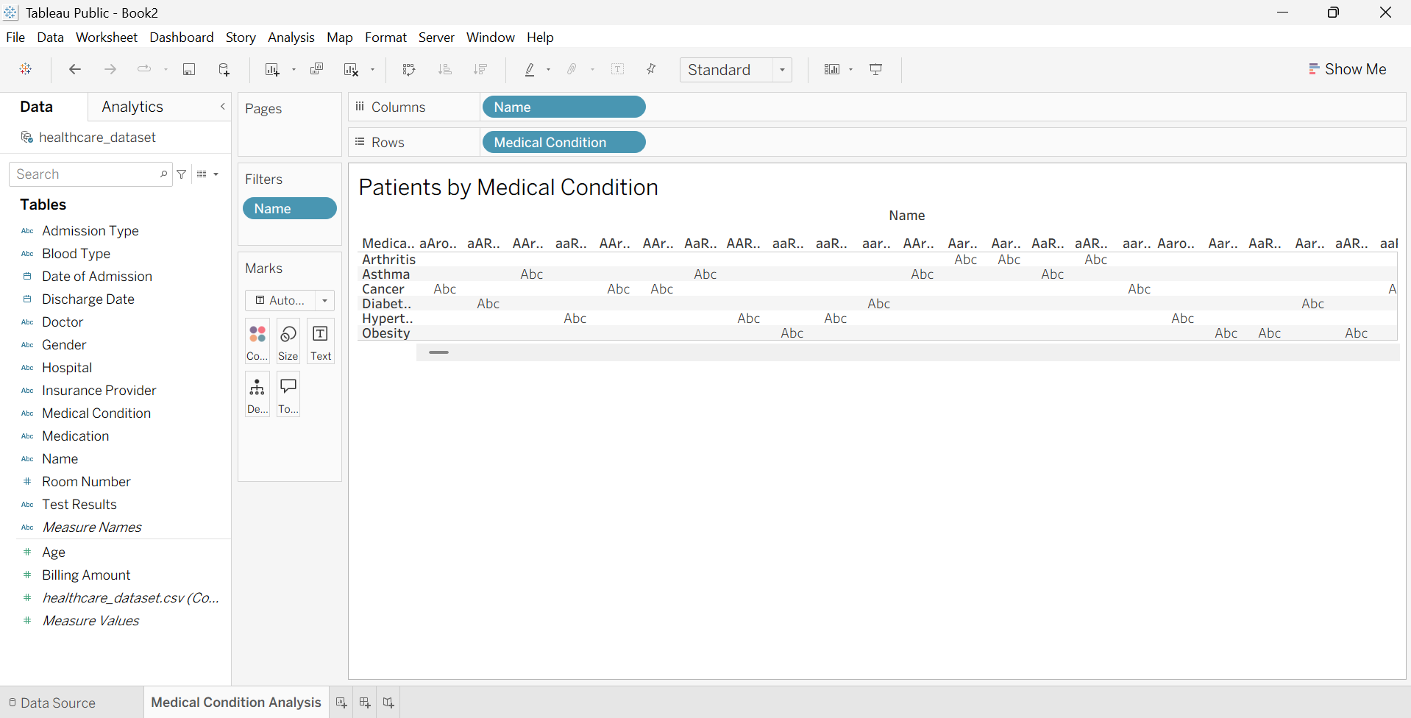

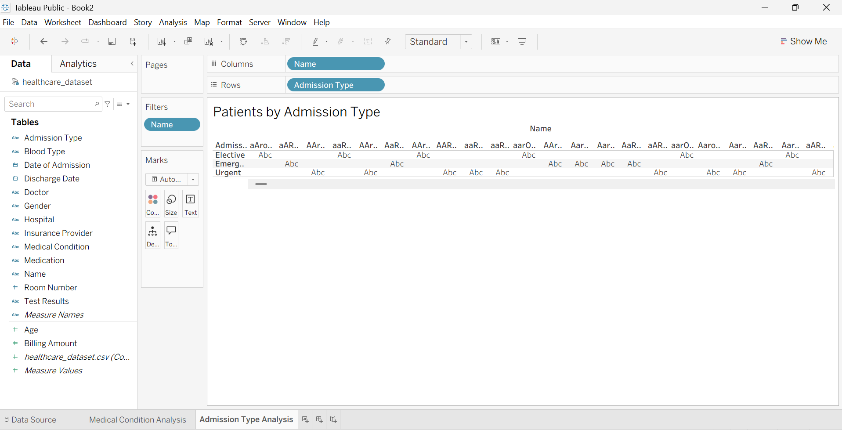

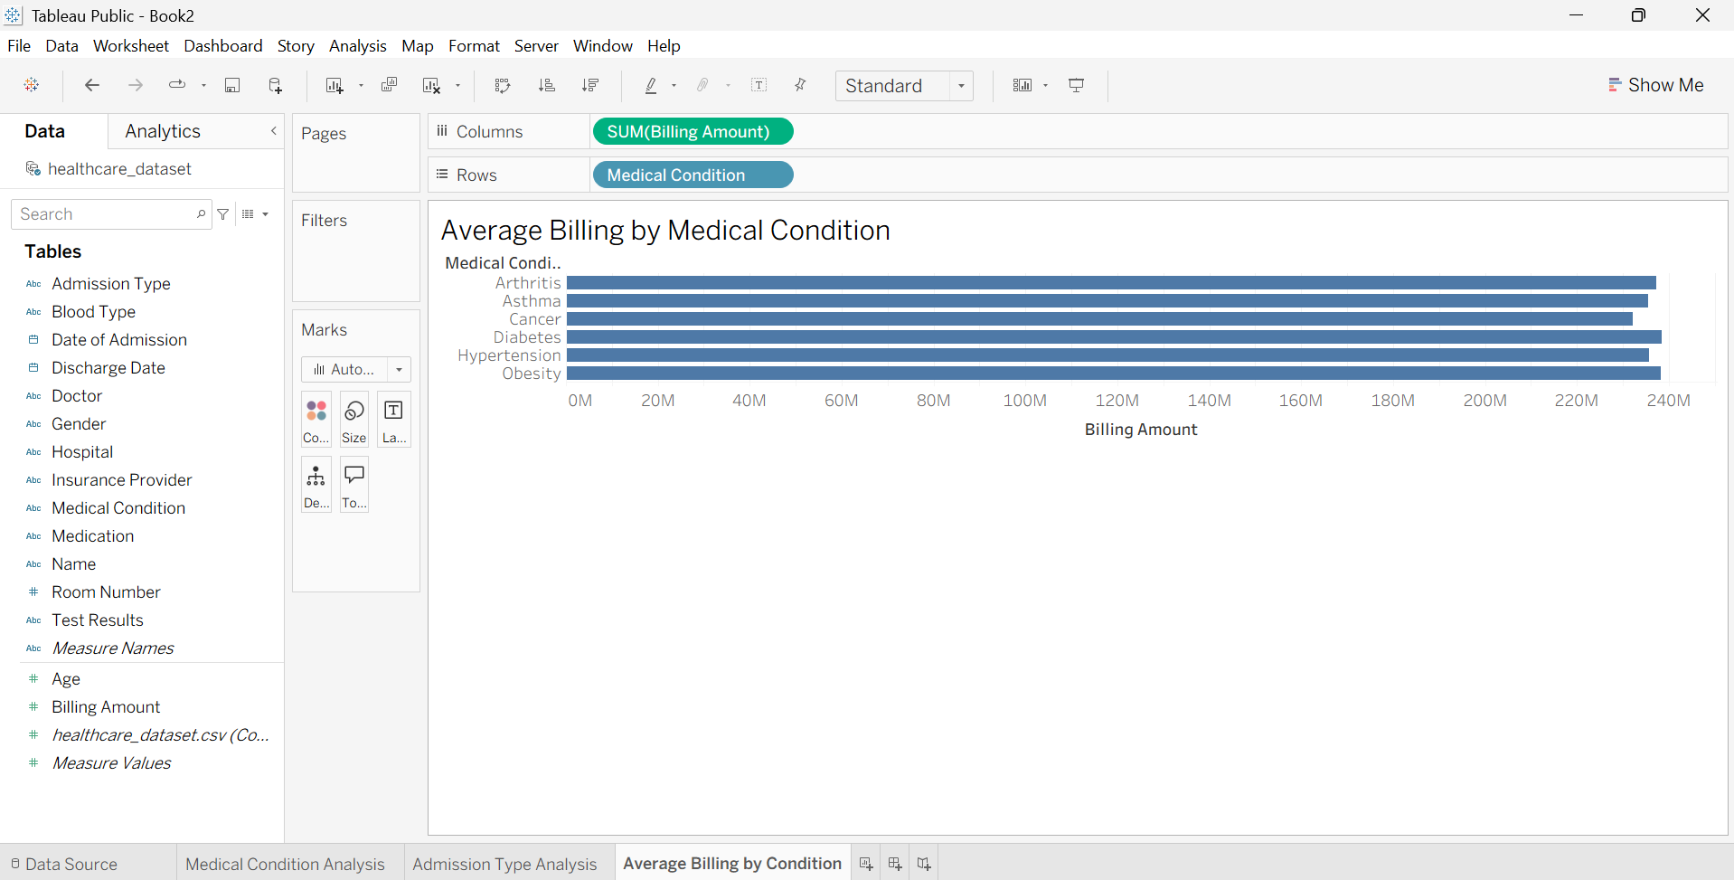
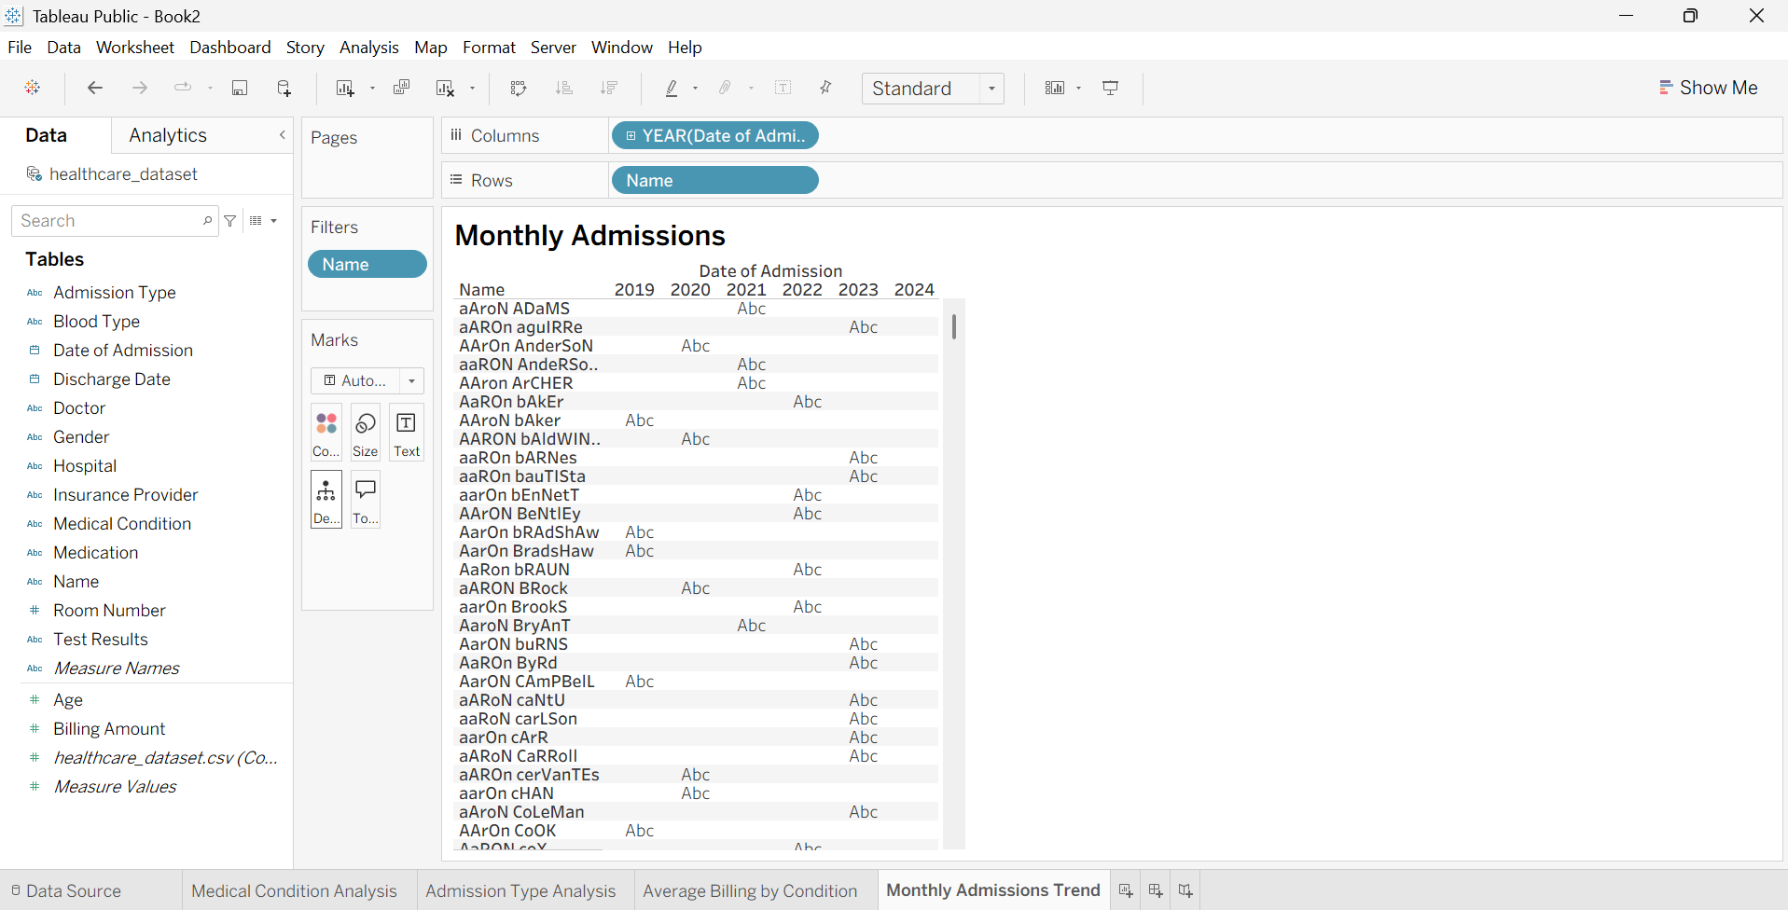
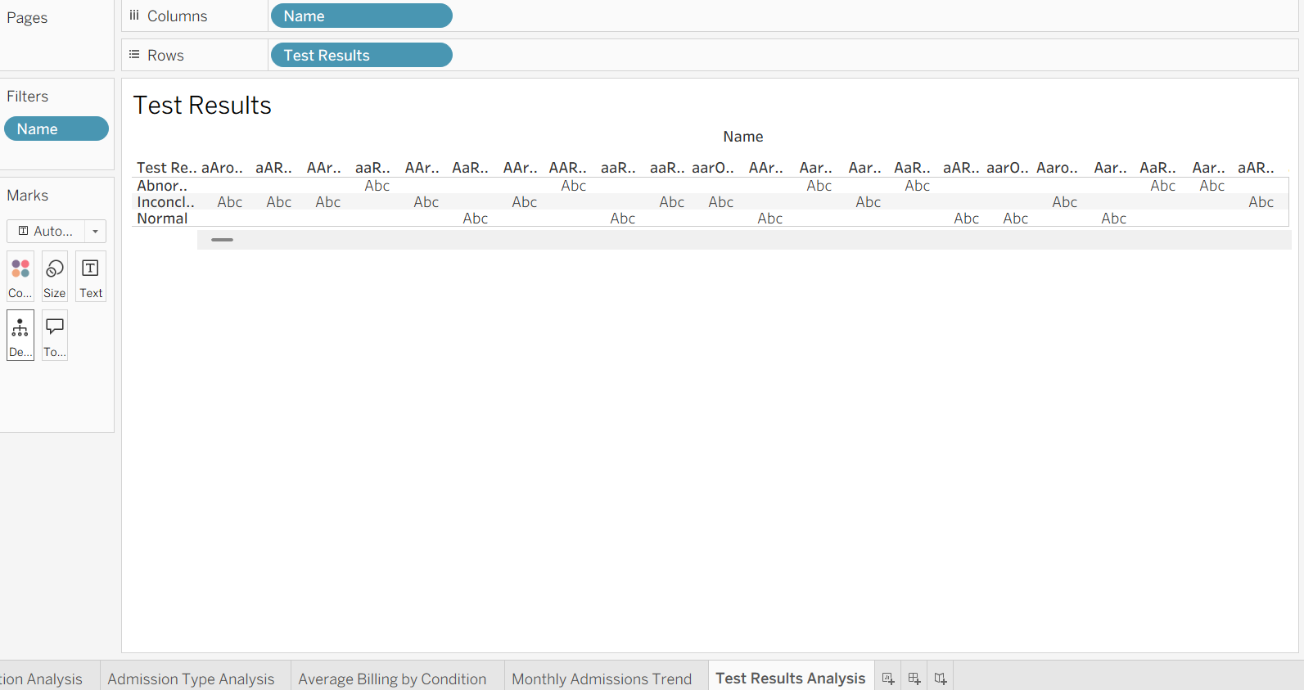

Result:

